**Integrative approach quantifying the conservation potential of urchin removal for kelp restoration**

**Description of the Biological Problem:**

Coastal kelp forests are some of the most biologically abundant, productive, and ecologically important systems in the world1. However, dramatic increases in sea urchin abundance are one of the main drivers of kelp deforestation in temperate mid-latitudinal regions, which can result in ‘urchin barrens’1. Such barrens not only negatively impact surrounding biodiversity, but also livelihoods, including wild fisheries and recreation. Urchins without their primary food source (kelp) also become barren themselves, where gametogenesis is significantly reduced. In response to global urchin proliferation, many conservation efforts have been deployed to address the negative effects of kelp deforestation, with varying levels of success2.

A new solution proposed to reduce overgrazing of kelp forests is urchin ranching, which involves the manual removal (fishing) of purple urchins *Strongylocentrotus purpuratus* from kelp-dependent rocky reef ecosystems, growing out their gonads (ca. 12-15 wks) -- the consumed portion of urchin known as “uni” or roe -- and bringing them to market. Taking into consideration the spatial influence of conservation efforts in places like California, where top-down predator control appears to be weak3, urchin ranching presents as an affordable and ecologically logistical strategy, however, its efficacy as a conservation approach is currently unquantified and poorly understood4. While the scientific community has recently made great strides in understanding the causes and consequences of regime shifts5 of coastal kelp forests, it remains highly uncertain if and at what scale urchin removal can increase kelp biomass and restore kelp ecosystems, and whether conservation benefits can be maintained alongside a new seafood production system. Therefore, if the goal of urchin ranching operations is to significantly diminish urchin populations, it is crucial to identify the trade-offs and limitations inherent to this strategy, which requires an investigation into the balance between conservation prospects and market longevity.

**Diagrams:**

Urchin Biomass : Kelp biomass:

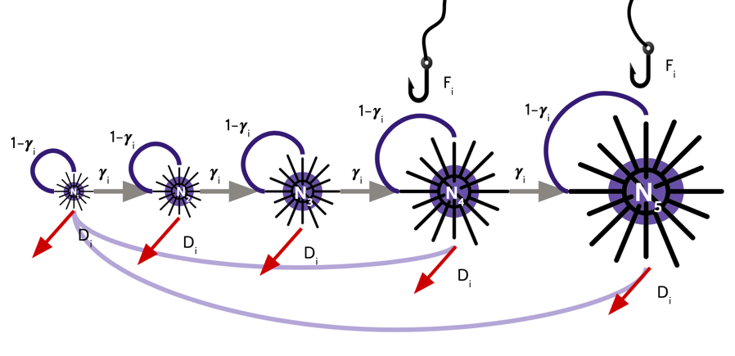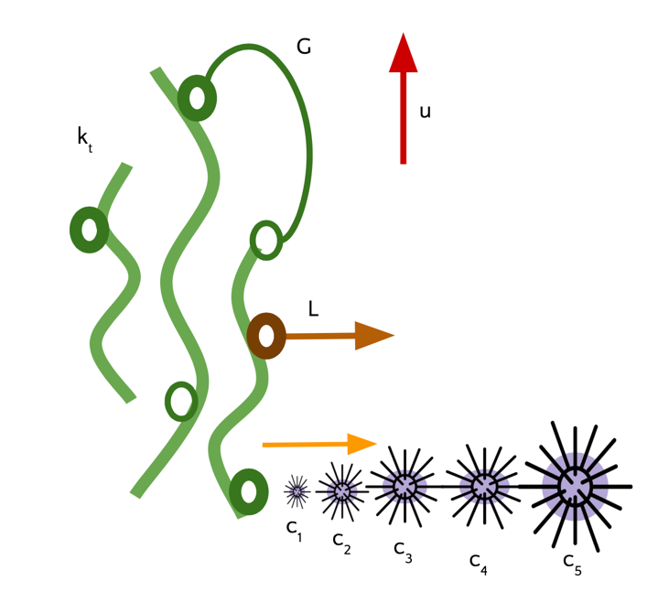

**Equations:**

1. Size stage-based model to predict urchin population growth. Population growth within each size class is a function of incoming individuals from either recruitment or the previous size class, survivability based on fishing and natural mortality (Z), and then a probability (gamma) that over the course of the year urchins will transition into the next size class based on age-specific growth rates and kelp abundance.
$${\left[\begin{matrix}{\left(1-γ_{1}M_{t}\right)e}^{-Z_{1}} & {γ_{1}M_{t}e}^{-Z_{1}} & 0 & 0 & 0 \\ 0 & {\left(1-γ_{2}M_{t}\right)e}^{-Z_{2}} & {γ_{2}M_{t}e}^{-Z_{2}} & 0 & 0 \\ 0 & 0 & {\left(1-γ_{3}M_{t}\right)e}^{-Z_{3}} & {γ_{3}M_{t}e}^{-Z_{3}} & 0 \\ 0 & 0 & 0 & {\left(1-γ_{4}M_{t}\right)e}^{-Z_{4}} & {γ_{4}M_{t}e}^{-Z_{4}} \\ 0 & 0 & 0 & 0 & {\left(1-γ_{5}M_{t}\right)e}^{-Z_{5}}\end{matrix}\right]}^{t}∙\left[\begin{matrix}N_{1,t} \\ N_{2,t} \\ N_{3,t} \\ N_{4,t} \\ N_{5,t}\end{matrix}\right]=\left[\begin{matrix}N_{1,t+1}-recruitment \\ N_{2,t+1} \\ N_{3,t+1} \\ N_{4,t+1} \\ N_{5,t+1}\end{matrix}\right]$$

2. Surviving recruits (within a closed system) that will be added to the N1 size class as a function of the number of reproductive individuals from the N4 and N5 size classes, proportion of females within those size classes, and survivability.
$$Recruitment=\sum_{i=4, 5}^{n}{N_{i,t}F_{i}}∂_{i}Φ_{i,t}$$

3. Effective reproductive ratio based on the ratio of males to females in a population and the half-saturation constant for the ERR.
$$Φ_{i,t}=\frac{ρ}{η+ρ}$$

4. Proportion of kelp available to the amount necessary to feed all of the urchins throughout the year (on average an urchin will eat ~450 g of kelp per year).
$$M_{t}=\frac{k_{t} }{N_{t}∙450}$$

5. Predicted loss due to fishing and natural mortality
$$Z_{i}=F_{i}+D_{i}$$

6. Kelp biomass growth over time as the result of a discrete logistic growth function with reductions due to size-specific consumption rates from urchins and harvest.
$$k_{t+1}=\left[1+R\left(1-\frac{k_{t}}{K}\right)\right]k_{t}-uk_{t}- {[(N}_{1,t}c_{1}+N_{2,t}c_{2}+N_{3,t}c_{3}+N_{4,t}c_{4}+N_{5,t}c_{5})k_{t}]$$

7. Harvest as a function of catchability and effort.

$$u_{k}=q_{k}∙e_{k}$$

**Table of all Parameters and State variables:**

|  |  |  |  |
| --- | --- | --- | --- |
| type | syntax | units | description |
| parameter | $$γ_{i}$$ | NA | $probability surving population will grow into the next size class$ based on growth rate |
| parameter | $$F_{i}$$ | NA | fishing removal probability (Froehlich) (Barnoff) |
| parameter | $$D_{i}$$ | NA | natural mortality probability (Froehlich) (Barnoff) |
| parameter | $$M_{t}$$ | NA | urchin growth probability based on kelp biomass |
| parameter | $$F_{i}$$ | NA | fecundity of females at size i |
| parameter | $$∂_{i}$$ | NA | proportion of mature females at size i |
| parameter | $$Φ_{i,t}$$ | NA | effective reproductive ratio |
| parameter | $$ρ$$ | NA | The ratio of females to males (0.5 assuming half of the population is female) |
| parameter | $$η$$ |  | Half saturation constant for “effective reproductive ratio” |
| parameter | *R* | $$\frac{g}{year}$$ | growth rate of kelp |
| parameter | *K* | g | carrying capacity of kelp |
| parameter | *u* | g | harvest |
| parameter | *q* | $$\frac{g}{boat}$$ | catchability |
| parameter | *e* | boat | fishing effort |
| parameter | $$c_{i}$$ | $$\frac{g}{year}$$ | consumption rate of urchins of size class i |
| parameter | *u* | g | harvest |
| parameter | *t* | year | time |
| state | $$k_{t}$$ | g | kelp biomass at time t |
| state | $$N_{i,t}$$ | # of urchins | number of urchins in size class i at time t |

**Brief Description of Future Analysis:**

Following the development of this model, I aim to determine equilibrium conditions for kelp and urchins through time without fishing and then evaluate how incorporating fishing dynamics changes equilibrium values for urchins and kelp throughout time. Once that is achieved, I intend to create a function in which fishing pressure changes as time moves on to mimic market growth (which I will model after both market projections and the past development of the similar red urchin fishery. In doing so I would additionally would like to figure out the amount of kelp necessary to support both in situ populations and farmed urchins which are held and grown for 12-15 weeks and compare that to the amount of kelp recovery (if any) predicted to occur on reefs.

**Citations which influenced the development of this model:**

Baranov T.I. (1918) **On the question of the biological basis of fisheries.** Nauch. Issledov. Iktiol. Inst. Izv. 1: 81-

128(Moscow).

Froehlich H.E., T.E. S.P. Essington, and McDonald (2017). When Does Hypoxia Affect Management

Performance of a Fishery?. *Canadian Journal of Fisheries and Aquatic Sciences*. 74: 922-932.

Rees, M. and S. P. Ellner. (2009) II.1 Age-Structured and Stage-Structured Population Dynamics. *The*

*Princeton Guide to Ecology*. Princeton: Princeton University Press, 155-165.

Von Bertalanffy L. (1957)  Quantitative laws in metabolism and growth. *Quarterly Reviews of*

*Biology.*32:217–231.